mcHF notes on the RF transmitter and SWR meter

We list below some modifications we've made on our three MCHF and that led us to make it work better in the transmission.
All this work was done after arranging the low-pass filters and band pass filters, as previously explained in the notes on filters

T4 Transformer

T4 consists of a CX2074, a small signal wide-band transformer
We observed that if it was necessary to replace the T5 with a transformer wound on a larger core, probably it was convenient to do the same thing with the T4.
The cx2074 winding consists of 4 turns of three twisted wires, connected as shown in the drawing; with 8 turns on the primary, and 4 turn to the secondary it has a transformation ratio 8/4=2 and an impedance ratio of 2² =4:1.
We took three AWG30 enameled wire 20 cm long , we have colored them with permanent markers to recognize them, after being twisted , we did four turns in a BN43-2402 helping with a toothpick and replaced the cx2074.

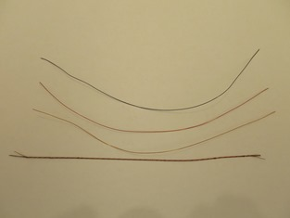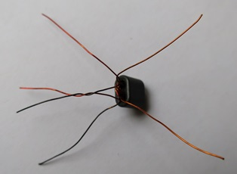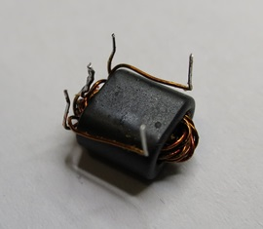

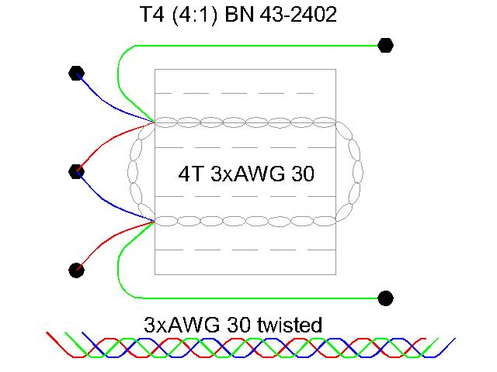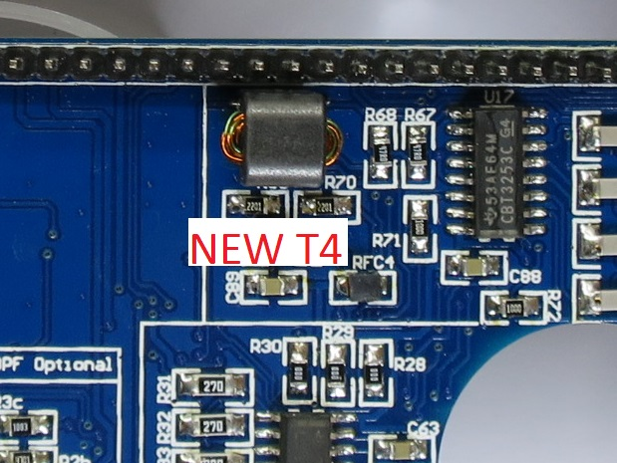

We compared the voltage measurements made ​​before with an RF probe, noting that we only had an increase of 0.4 volts in an average value at the transmitter output.

RFC5-RFC6

We noticed that RFC5 and RFC6 that had a value of 47 uH have been replaced with three turns of enameled wire on BN61-2402, but three coils give a value of only 2.25 uH ( see www.toroids.info ), too low to stop the rf on the collectors of the driver at the higher frequencies.
We replaced the BN61-2402 with BN43-2402 with 6 turns of enameled wire AWG 28 that have an impedance of 51 uH and the situation is much improved at high frequencies.
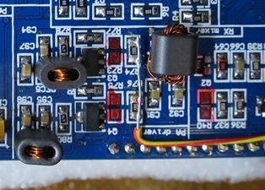
T5 Transformer

About transformer T5 has been much debate and almost everyone as we finally installed the transformer suggested by Klint
To us it seemed odd that switching to an impedance ratio 4: 1 (50 ohm filter side -> 12,5 ohm driver side) compared to a 1: 1 ratio calculated originally by Chris it was definitely better (50 ohm filter side -> 50 ohm driver side).
We did some tests , from 4: 1 transformer of Klint up to the 1: 1 transformer of Chris , using 8 different transformers all wound up BN43-2402
The best result in terms of power , was obtained with a transformer which has 5 turns on the primary and 2 + 2 turns on the secondary and an impedance ratio equal to ( 5/4 ) ² = 1.56 : 1 constructed as shown in the drawing and in the following images.

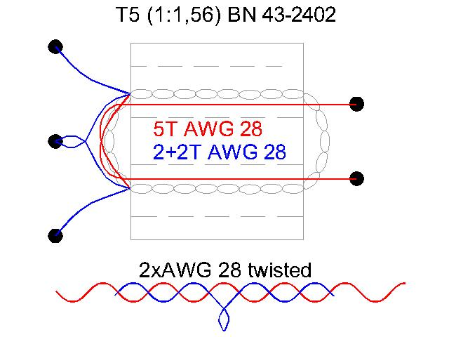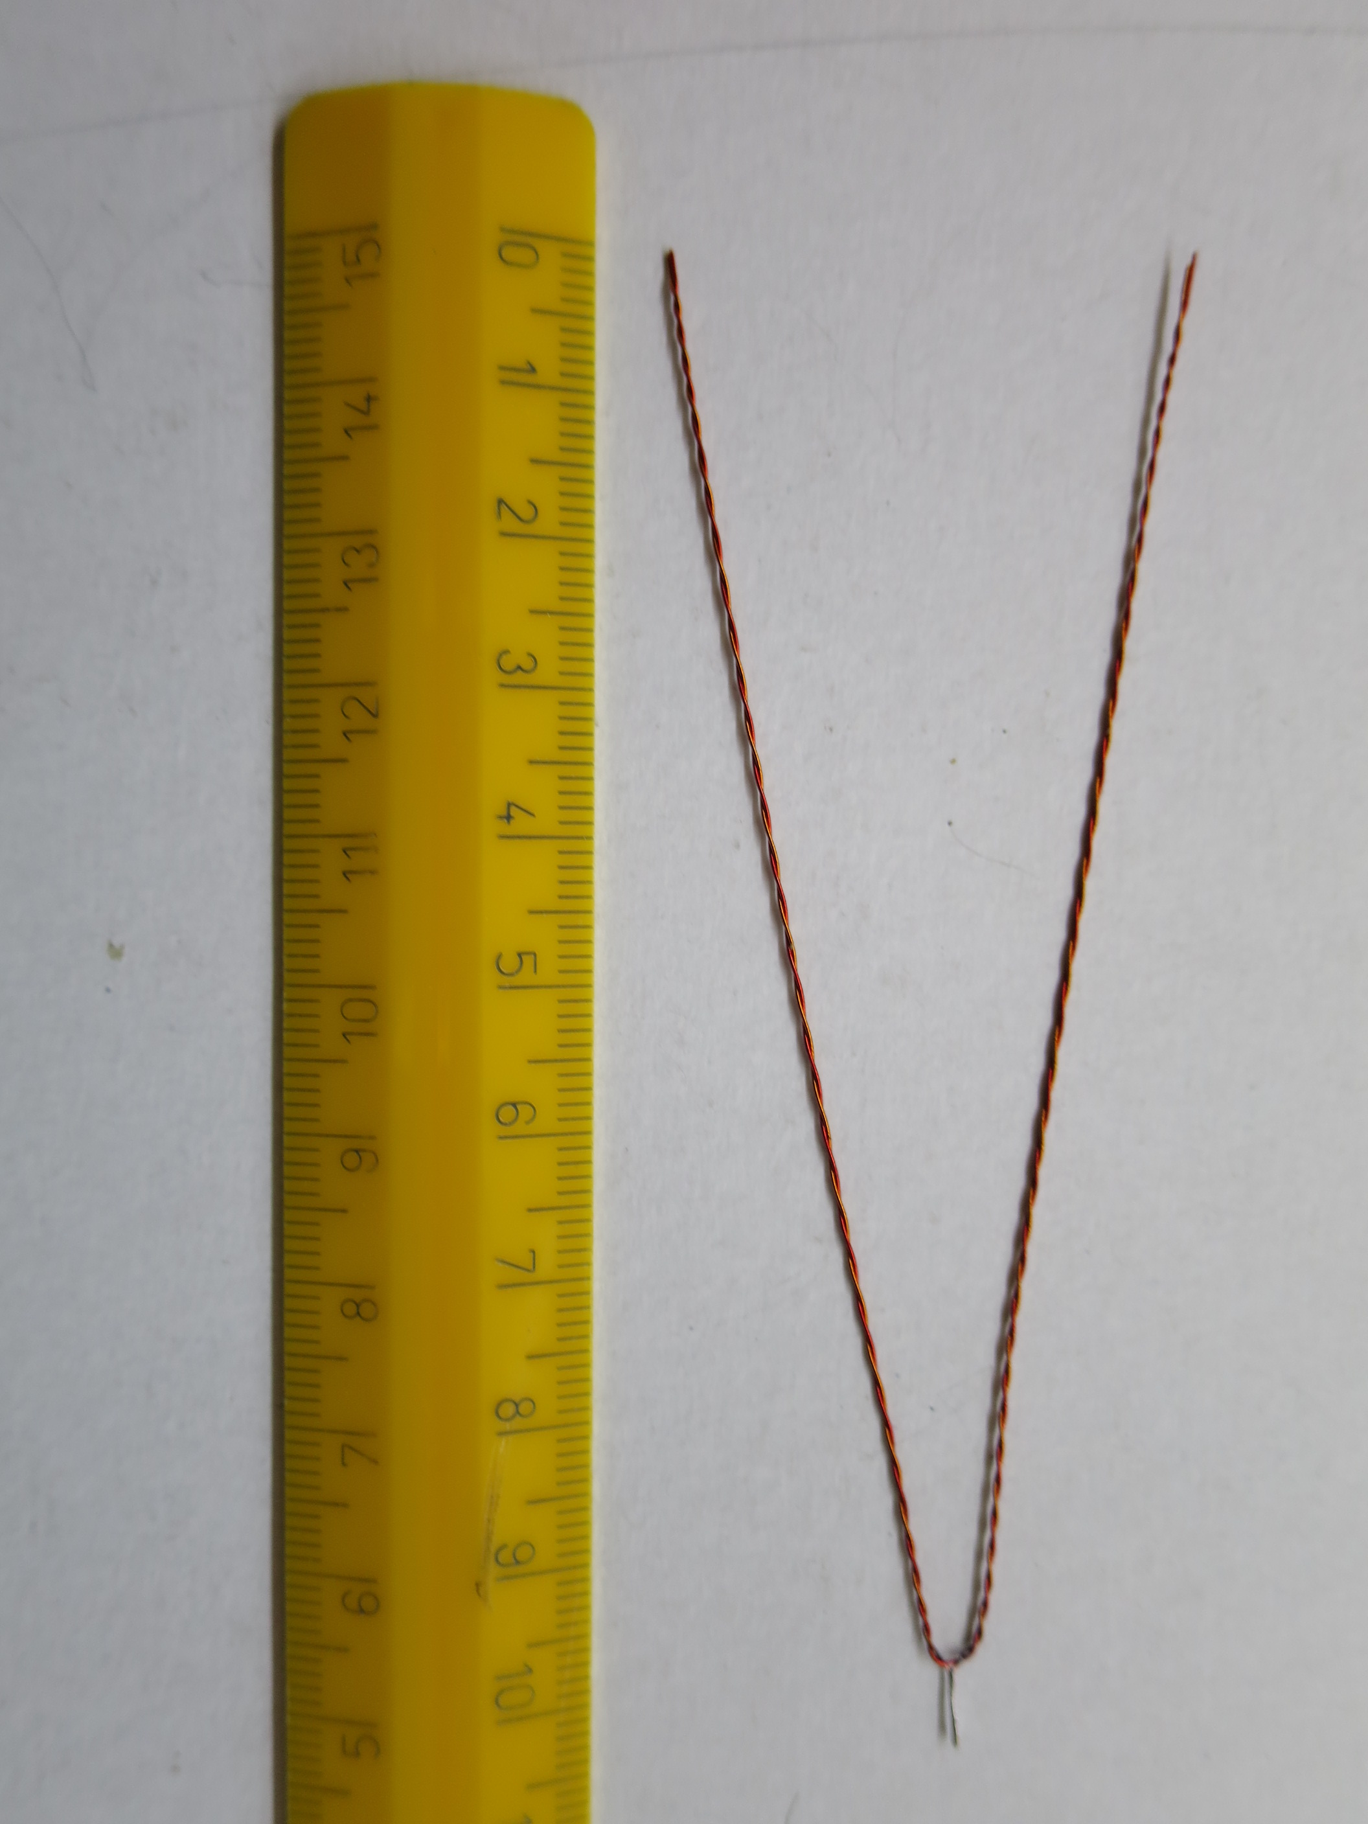

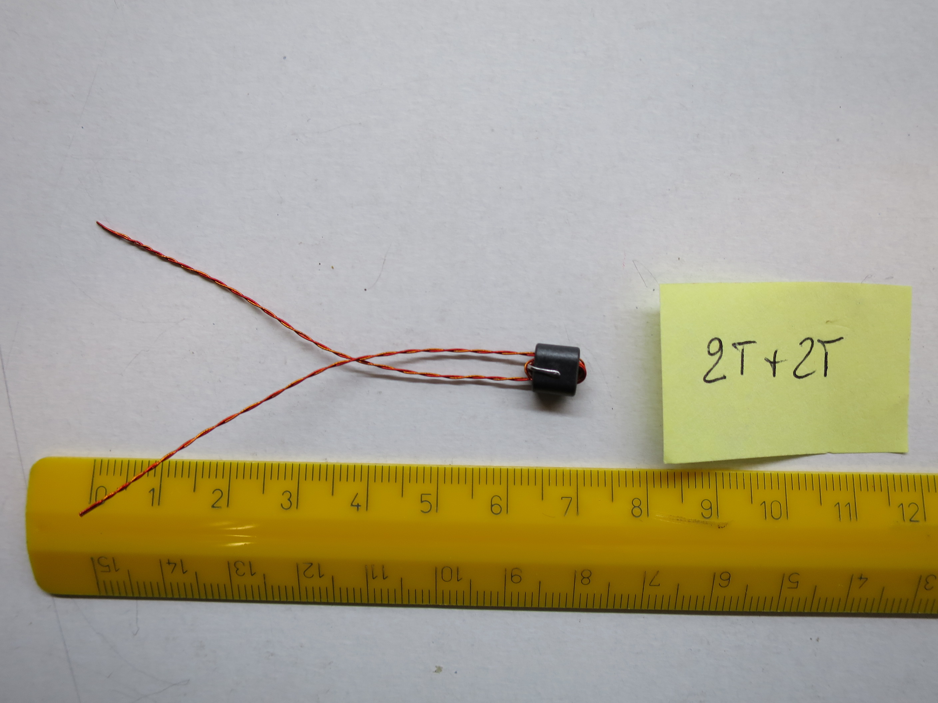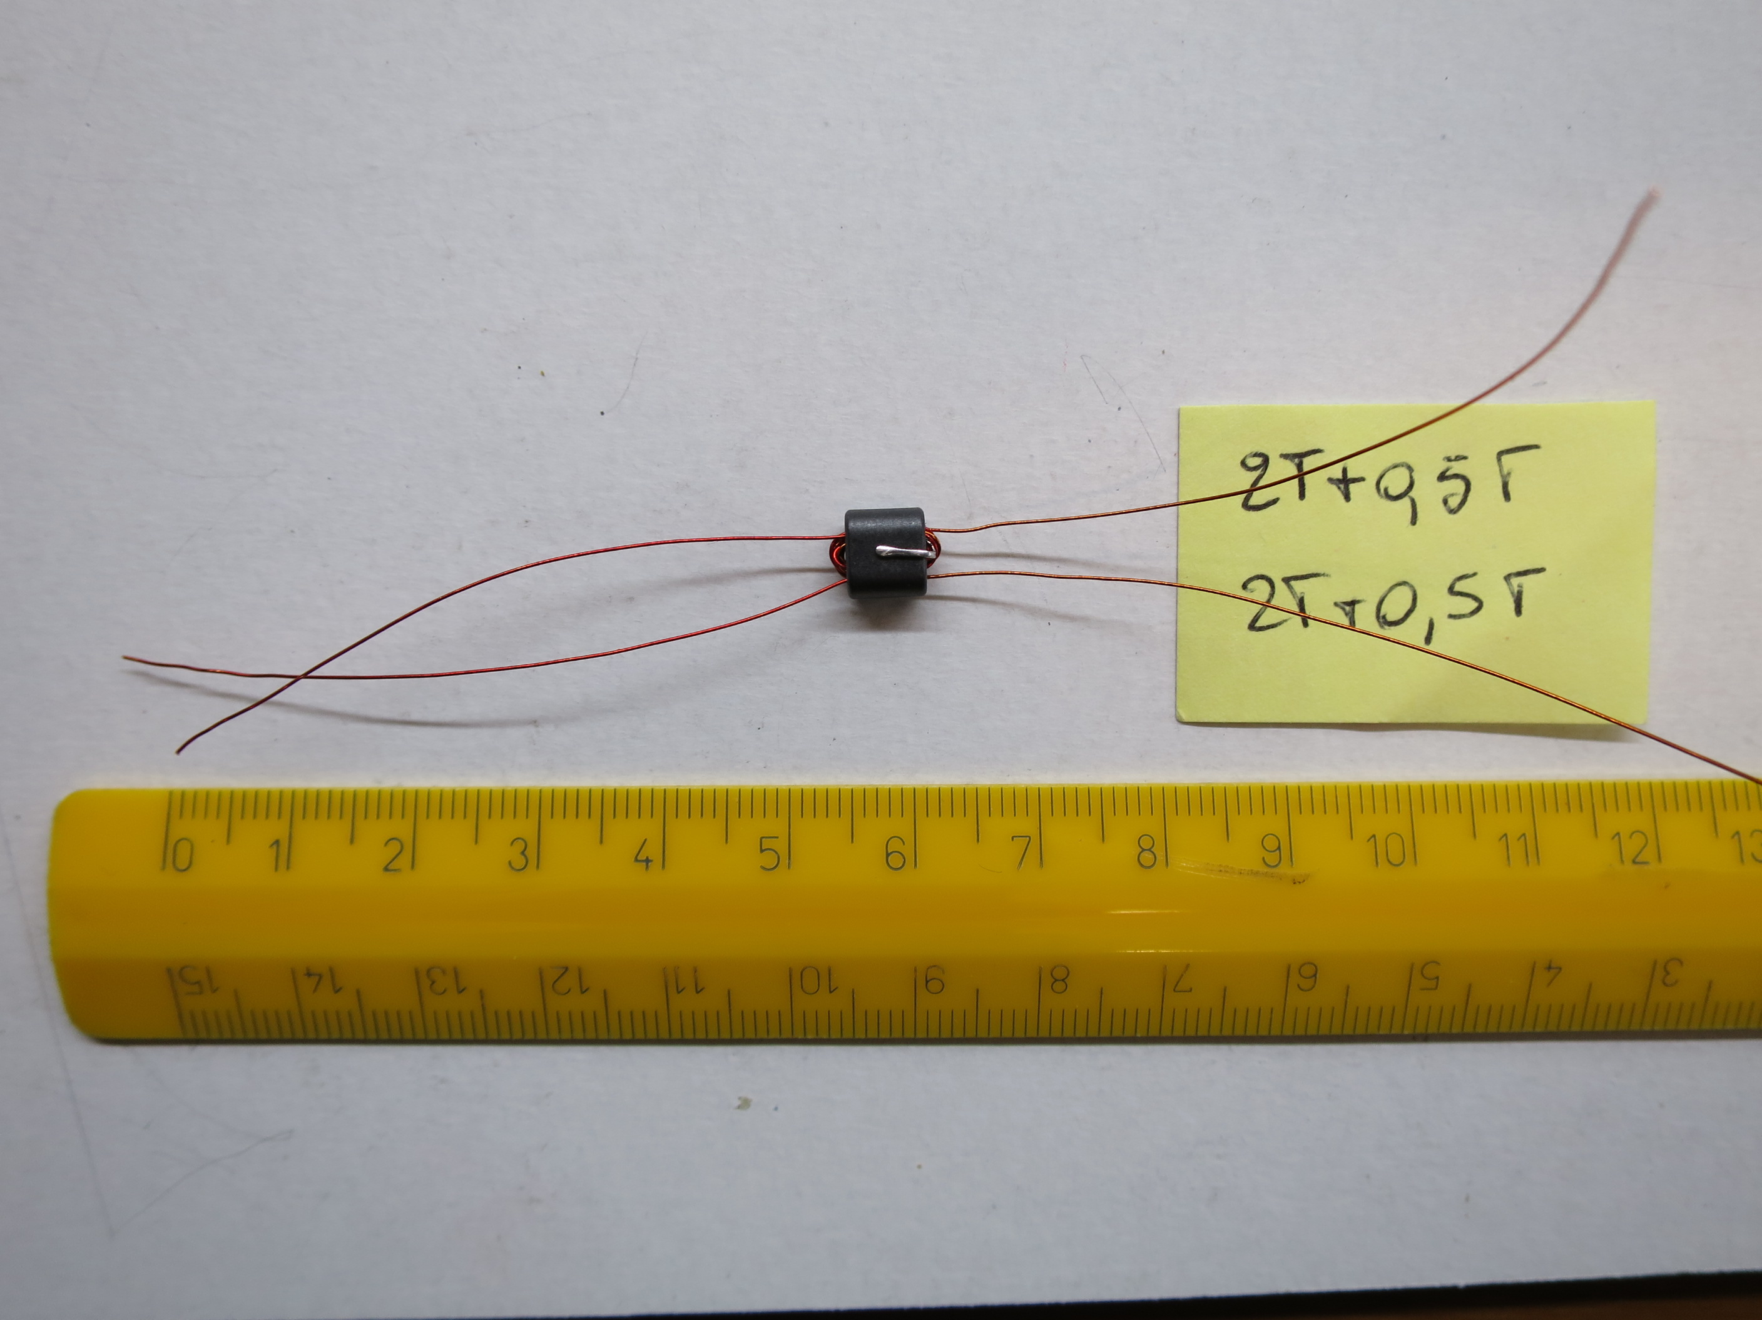

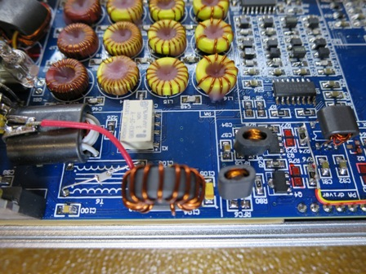
T5 Installed
T6 & T7 Transformer

We made the configuration of T6 and T7 suggested in the Yahoo group , but it seemed too complex and with a strange double power supply of FET, by T6 and RFC8.
Intrigued us that the Zeus ZS-1 with a transformer made ​​with only a BN43-202 transmits from 160 to 10 m with an rf power of 15 W. We found that the distinction is all in the type of transformer winding.
In the primary of the transformer are 2 + 2 turns in parallel and in phase opposition , in the secondary of the transformer are 4 turns, as better illustrated in the following scheme

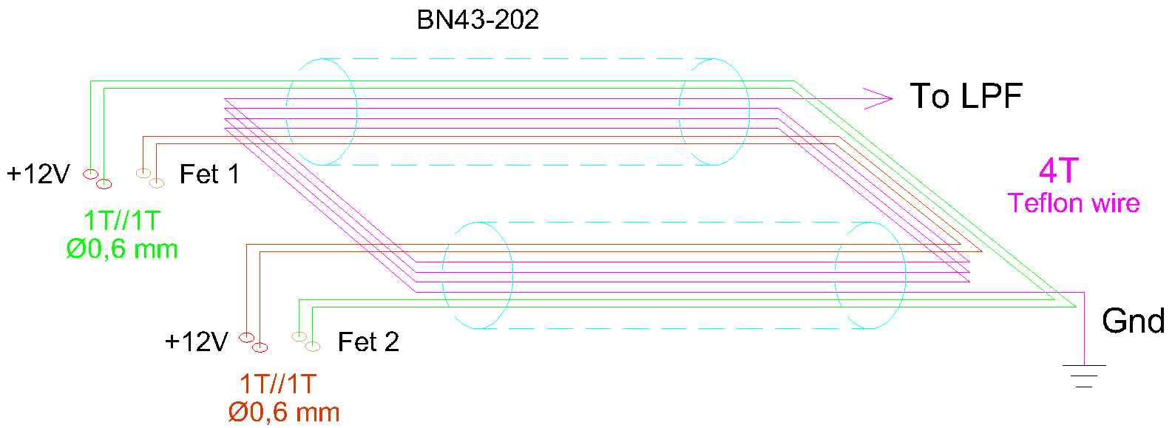

The power supply of the T7 transformer is then made ​​with a toroid FT50-43 (to be installed in replacement of RFC8) on which are wound 14 turns of enamelled copper wire 0.6 mm, and is filtered by a capacitor tantalum 10 uF 35 V in parallel to another from 0.1 uF capacitor 100V (installed near T7) as shown in the following diagram.

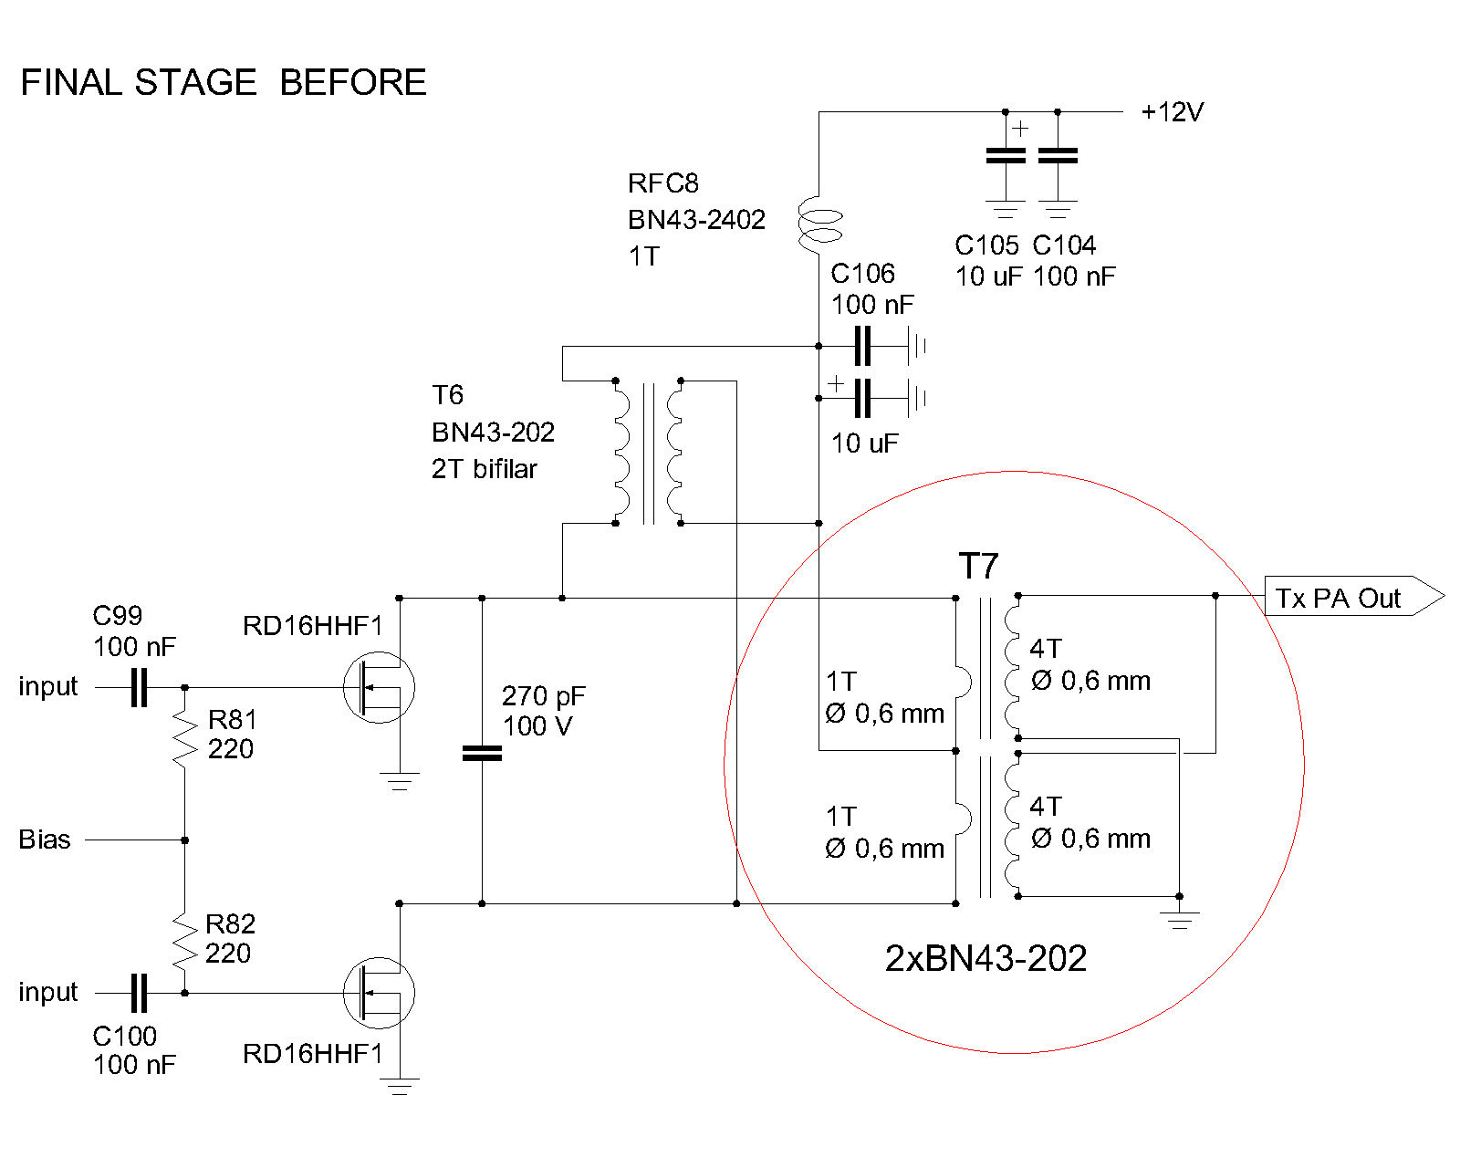
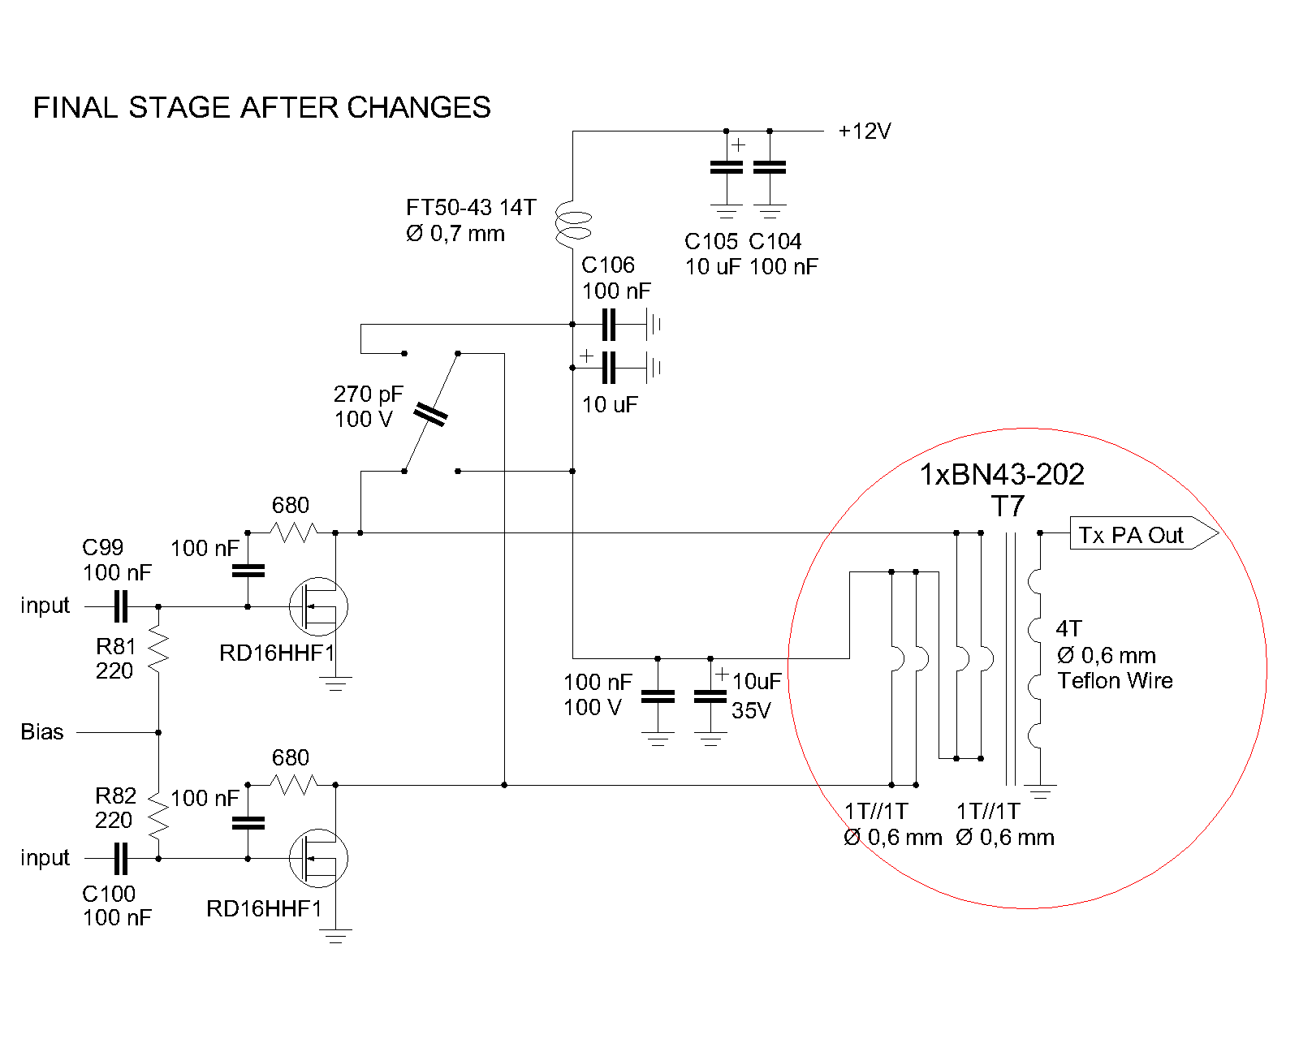
Because everything works well , it was necessary to add a feedback on the gate of the FET consists of a 100 nF capacitor in series with a resistance of 680 ohms; in the original scheme of the resistance was 510 ohms but after several tests it was found that on MCHF works better 680 ohm.
Even in this new configuration, you must install the 270 pf capacitor which happens to be the optimal value , after we tried capacitor from 180 pF to 330 pF.
The following photos show the old and the new configuration and how to assemble T7.

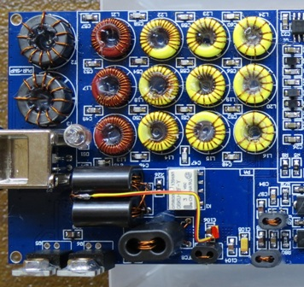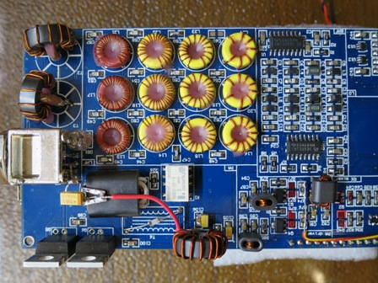

RF PCB Before RF PCB After

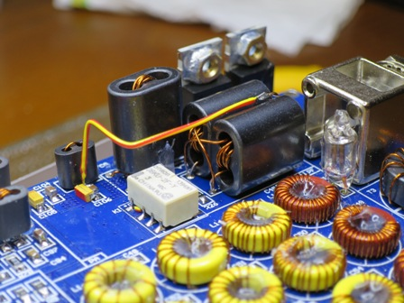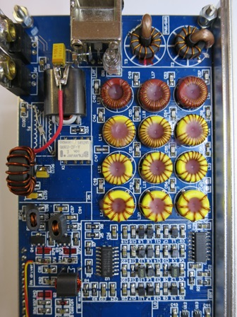

RF PCB Before RF PCB After

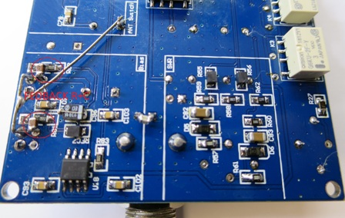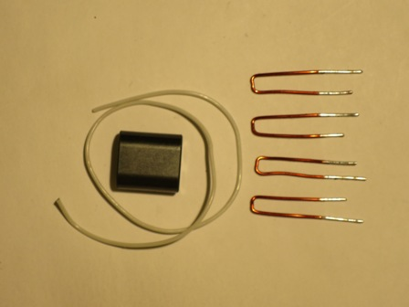

Fedback Res+Cond position New T7 Component

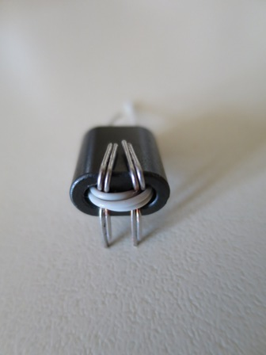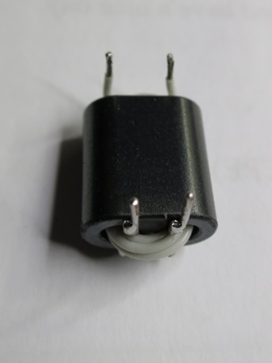

T7 Assembled T7 ready for welding

After installing everything you need to recalibrate the bias current of the FET.
Remember to install the capacitor and the feedback resistor otherwise your FET go up in smoke , as has happened to me when I made ​​the changes to one of our thre mcHF.
The new T7 works very well and our mcHF with a bias current of 500 mA and a pair of matched FET allows us to have 10 W to the antenna at 13.2 V power supply with the following power adjustments 80m=20, 60m=27, 40m= 22, 30m=24, 20m=34, 17m=42, 15m=54, 12m= 85, 10m=85; only 10 m power is reduced to 9.5 W.
For more linearity and more power on the high bands it will be necessary to provide for the future rev. 5 of rf pcb an amplifier stage in more first drivers.

SWR-Meter modification

The SWR-Meter of MCHF is probably the most difficult to fix.
We, like all those participating in the Yahoo group did a thousand changes on toroids hoping to successfully operate the SWR - meter on 10 m;
A strange phenomenon was that changing the toroids FT 50-43 FT with FT 37-43 or FT 37-61 or BN43-302, standing waves on 10 meters were always between 1 : 1.75 and 1 : 2 , even if they were trying to shield them or installing them in vertical.
The situation was only slightly improved with the introduction of shielded cables.
Then I happened to read a very interesting article that you can find at http://www.giangrandi.ch/electronics/ tandemmatch/tandemmatch.shtml which explains very well the operation of the tandem match as well as an article of G4ZNQ which you can find at http://www.sm7ucz.se/Meters/Stockton_pwr_meter.pdf.

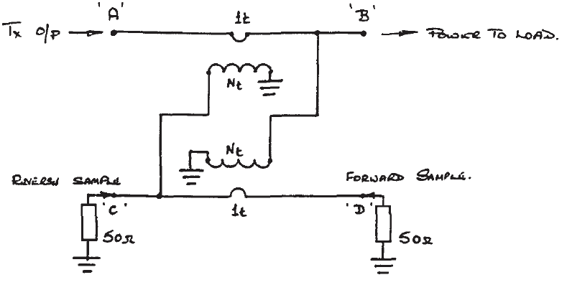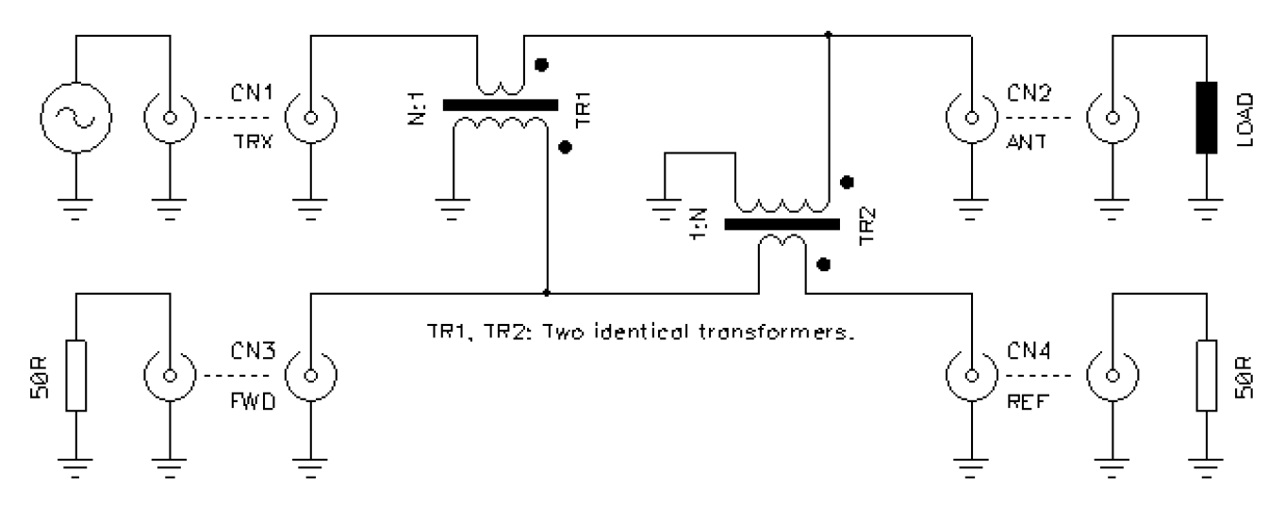
Stockton power bridge Directional coupler

Comparing the electrical diagrams in the two articles with the scheme of ' MCHF I realized that the hot pin of the voltage transformer must be connected by the antenna side , while on ' MCHF was connected on the transmitter side
Fortunately , the change was easy to do , as you can see in the photos below and standing waves on the 10 meters fell to 1 : 1.5.

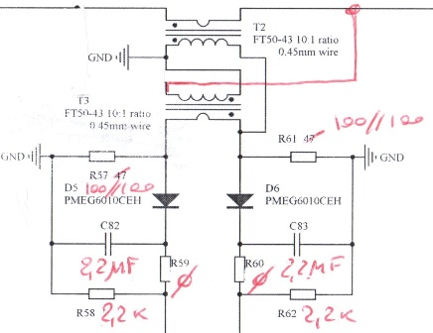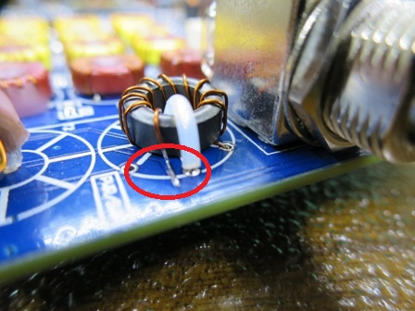

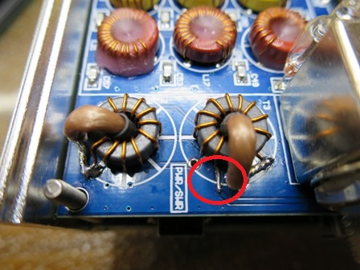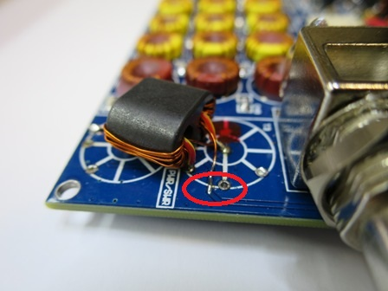

The fact that shielded cables improve the situation made ​​me think that they have a capacitance value proportional to its length which compensates the inductance values ​​of toroids.
To investigate we then installed a dummy load 50 ohm on the bnc unsoldered R37 and connected the antenna analyzer from the line side towards the tandem match.
The antenna analizer has measured a swr equal to about 1 : 1.3 with an indication of the inductive load an all our three mcHF.
So it was sufficient to install capacitors (18 pf for pcb with FT 37-43 ; 28 pf for pcb with BN 43-302) on BNC pins to bring the standing waves of the tandem match read by the analyzer to 1: 1.

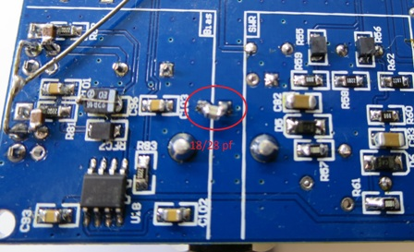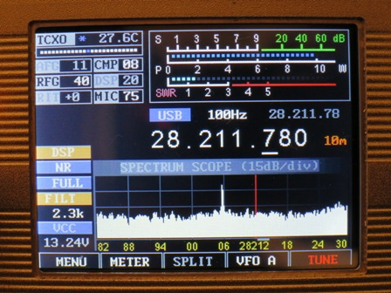

After all these changes that we have achieved is that the SWR meter reads 1 : 1.25 of standing waves when transmitting with full power on a dummy load of 50 ohms on 10 m, not so much , but we can be satisfied.
Probably the entire measurement chain of ' swr has some impedance mismatch or some non-linearity, due to the type of diode used (note that the PMEG6010GEH have a high capacity of about 68 PF against 2 PF of the BAS 70 of the Kx3 ) or due to the low impedance load ( 2.2 kohm against the usual 20 to 100 kilohms ).

Description of binocular tandem match

In the many tests carried out we have also made ​​a tandem match with ferrite binocular BN 43-302 easily installed on MCHF to test if the operation was better than that with toroids..
The installation of BN 43-302 must be very careful to the arrangement of the coils to be facing down otherwise the SWR grows, but the end result is the same as that of the individual toroids.
For those wishing to try , we attach the diagram and photos where you can see how it is installed

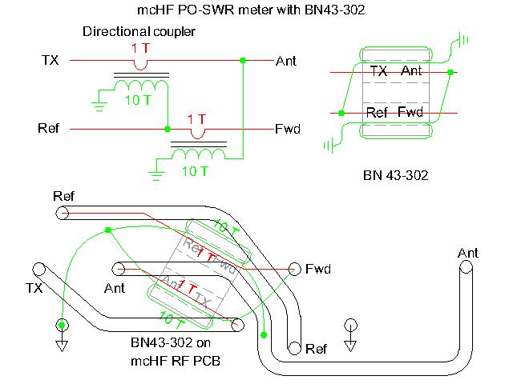

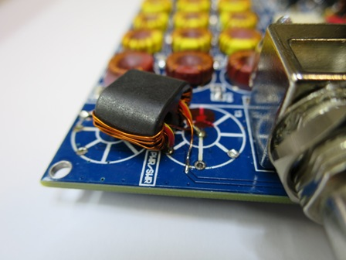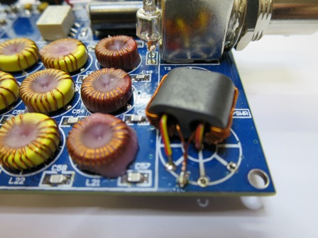

We do our best compliments and thanks to Chris and Klint that have allowed us to build these little jewelry that are giving us a lot of satisfaction

‘73 de Paolo IZ6MAF with the fundamental support of Gianluca IK6QOO

23th November 2015

